**Proposed Solution:**

Bio-inspired USV that efficiently collects surface waste from water bodies. The USV features biomimetic fin-based propulsion for agility and energy efficiency, allowing it to navigate smoothly through water with minimal disturbance. It incorporates a dual navigation system: manual control via a radio transmitter for primary navigation and autonomous mode using Pixhawk flight controller and Raspberrypi for more complex, pre-programmed waste collection routes. The primary mission is to aid in environmental clean-up efforts by collecting floating waste on water surfaces, such as plastic debris, leaves, and other pollutants.

**Conceptual Design Approach:**

**3D Model / Design:**

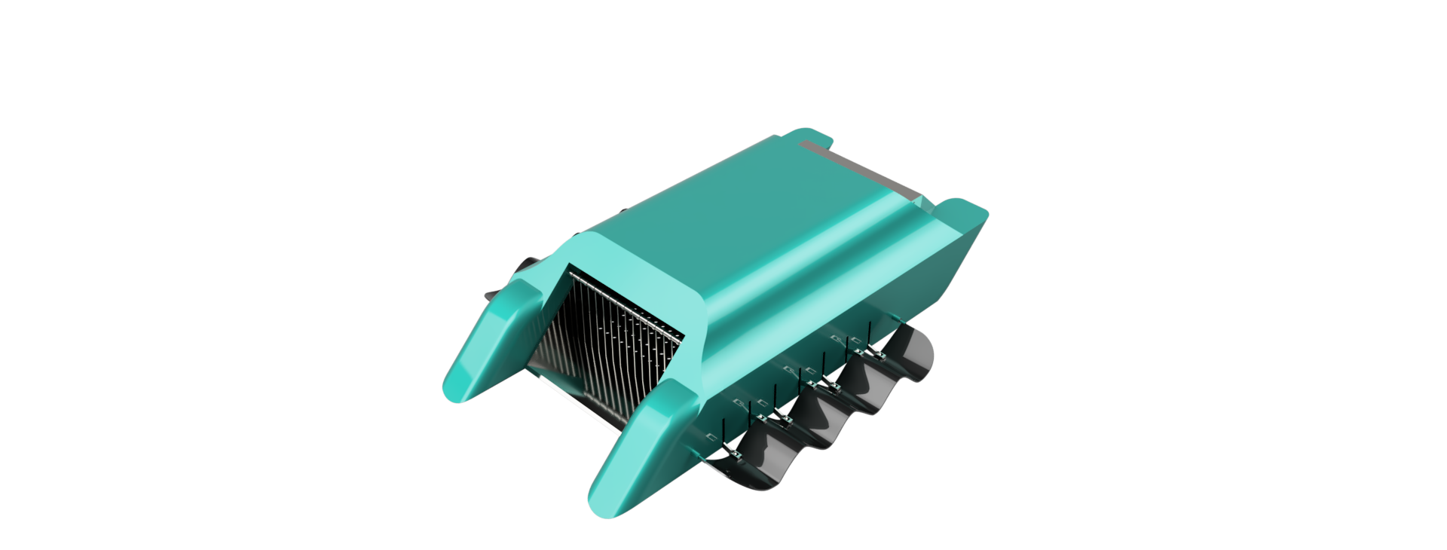

a) Isometric View

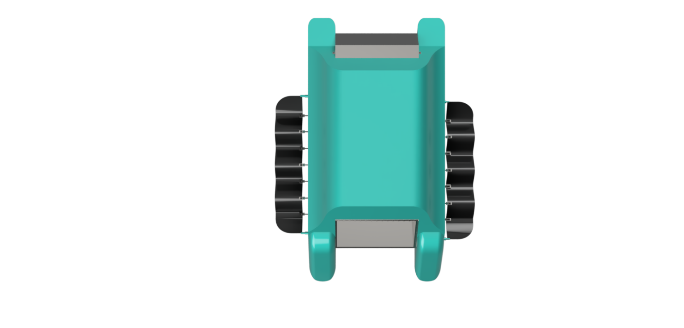

b) Top View

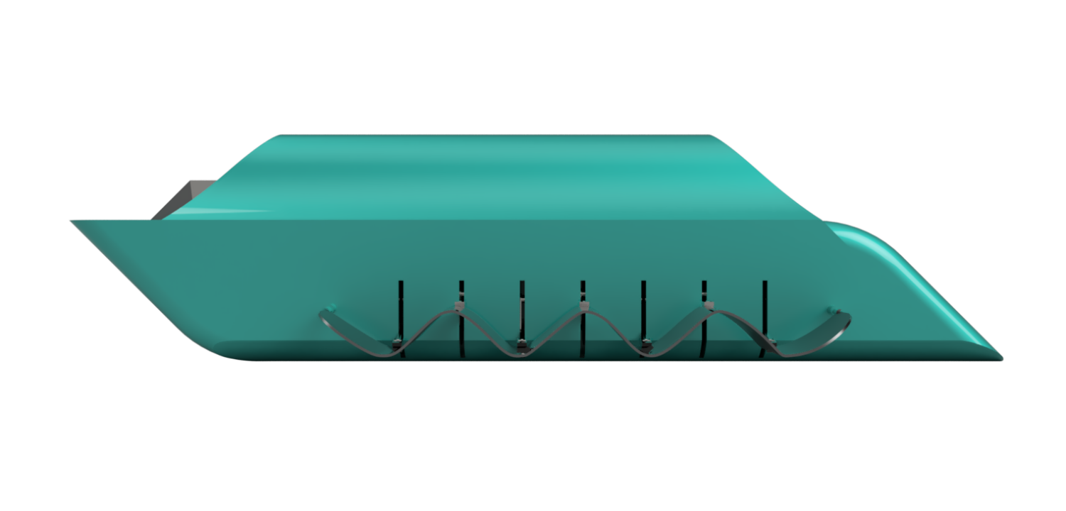

c) Side View

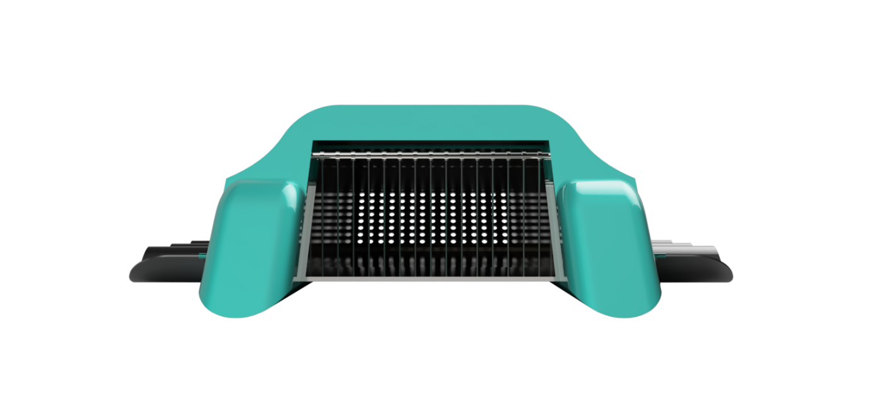

d) Front View

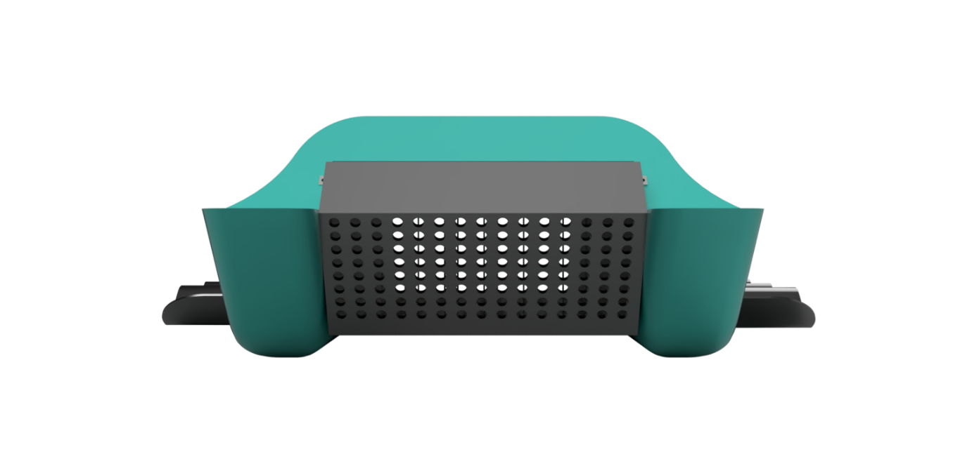

e) Back View

**2D Draft:**

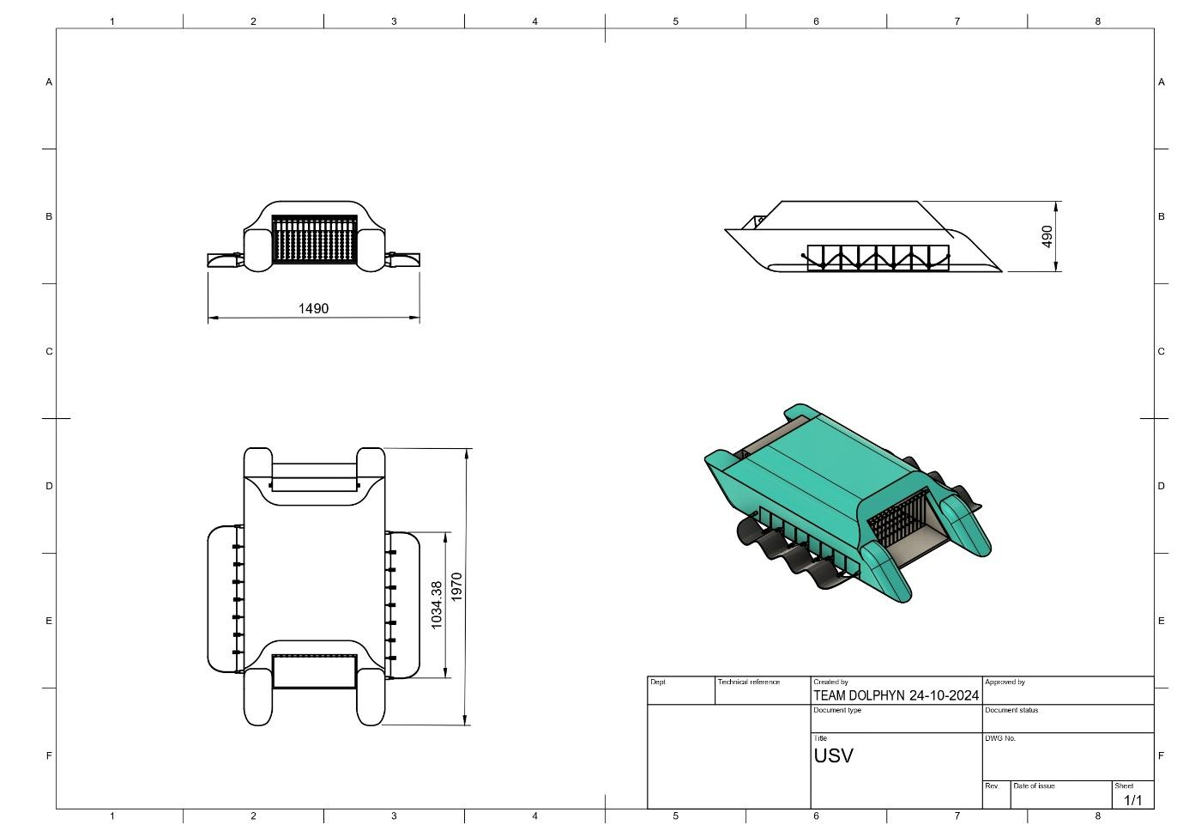

**Technical Requirements and Specifications:**

**Functional Requirements:**

1. **Primary Navigation via Radio Transmitter:** Allows for direct, manual control by the operator to navigate around large or concentrated waste areas.
2. **Autonomous Navigation using Pixhawk:** Capable of self-guided routes to follow predetermined paths along water surfaces for routine waste collection.
3. **Waste Collection Mechanism:** Equipped with a front-mounted One-Way Mechanical Barrier collection system that captures and stores floating debris.
4. **Bio-Inspired Undulating Fin from knife fish:** Designed for energy-efficient, low-disturbance movement, particularly beneficial in sensitive or ecologically significant areas.
5. **Obstacle Avoidance:** Equipped with Camera to detect and avoid obstacles such as rocks, buoys, or other vessels.

**Navigation and Control System:**

* In **manual mode** Pixhawk receives input from the radio transmitter, enabling direct control.
* In **autonomous mode,** Pixhawk manages movement based on GPS waypoints and real-time IMU adjustments, providing stability and autonomous navigation for waste collection.

1. **Waste Collection System:**

* **One-Way Mechanical Barrier:** Positioned at the front of the USV, this system includes a rake system that collects up floating debris as the USV moves through the water. The collected waste is stored in a detachable bin or basket located at the back of the USV for easy removal and disposal.
* **Mesh Filter:** A mesh filter integrated into the collection system ensures that only debris and waste are collected, allowing water to flow through and reducing drag on the vehicle.

1. **Propulsion System: Biomimetic Fin Design:**

Inspired by the efficient movement of marine animals, the fin-based propulsion system enhances maneuverability and minimizes disturbances in the water. The fins:

* Operate with **oscillating movement**, mimicking natural swimming, which reduces energy usage and maintains a quiet presence, avoiding excessive disruption to aquatic life.
* Provide **versatile maneuverability**, especially beneficial for navigating around obstacles or reaching confined spaces where waste tends to accumulate.

1. **Pixhawk 2.4.8 for Autonomous Stability and Control:**

* IMU (Inertial Measurement Unit): Provides stability control by tracking roll, pitch, and yaw, essential for steady movement and accurate waste collection.
* GPS Module: Enables precise navigation for autonomous operations, allowing the USV to follow defined paths or return to base when necessary.

1. **1080p HD Camera:**

* Integrated camera captures surface images for **obstacle detection** and **visual navigation** using YOLO v7 algorithms.

1. **Raspberry Pi as Companion Computer:**

* The **Raspberry Pi** serves as the companion computer, handling image processing (YOLO v7), sensor data integration, and supporting autonomous navigation alongside the Pixhawk controller.

1. **Waste Bin Full Detection:**

* An **IR sensor** detects when the waste bin is full, triggering the USV to return to the home position for unloading.

1. **Home Position for Waste Unloading:**

* The USV autonomously returns to a pre-programmed home position using Pixhawk and GPS waypoints for waste unloading.

**Hull Design and Structural Integrity**

**The hull is designed to ensure:**

* **Stability and Buoyancy:** Lightweight, corrosion-resistant materials are used for the hull to prevent rusting and degradation over time.
* **Waterproof Compartment for Electronics:** The Pixhawk, raspberry pi 4, GPS module and other control electronics are secured in a waterproof compartment using acrylic pipe enclosed by resin, ensuring safety and durability in aquatic environments.

**Software stacks:**

* **Autodesk** **Fusion 360**: Used for designing the USV components (hull, waste collection system, propulsion), including part modeling and assemblies.
* **ANSYS 2024 R1**: Analyzes structural integrity and hydrodynamics, simulating stress, strain, and fluid flow to ensure durability and efficiency.
* **QGroundControl**: Provides mission planning, waypoint navigation, and real-time telemetry for precise monitoring and control of the USV.
* **ROS 2**: Manages sensor integration (GPS, IMU, ultrasonic), processing data for autonomous navigation and obstacle avoidance.
* **Gazebo**: Simulates USV dynamics, navigation, and waste collection in 3D for design validation and optimization before deployment.
* **YOLO v7:** Processes visual input from the camera for real-time obstacle detection and navigation assistance.

**Electronic circuit Design:  
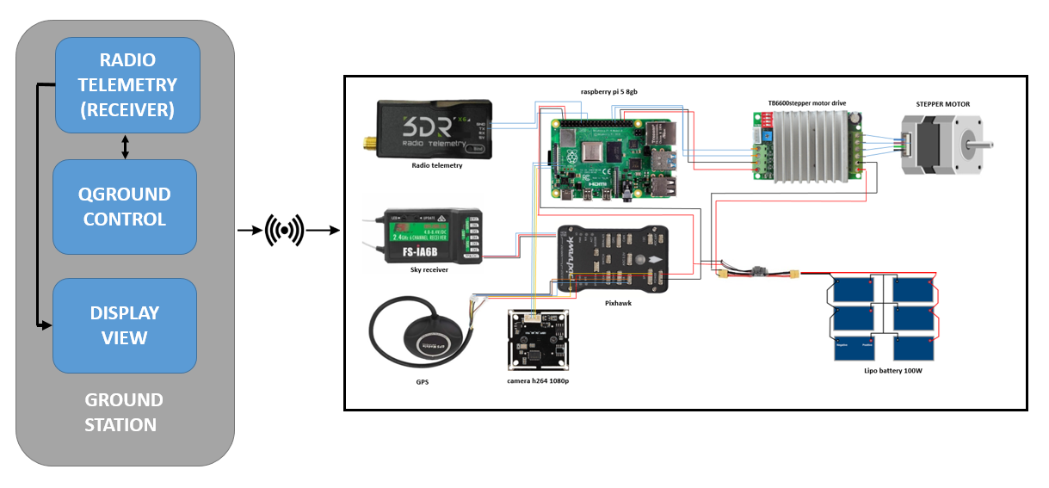**

**Theoretical Calculations:**

**1 2**

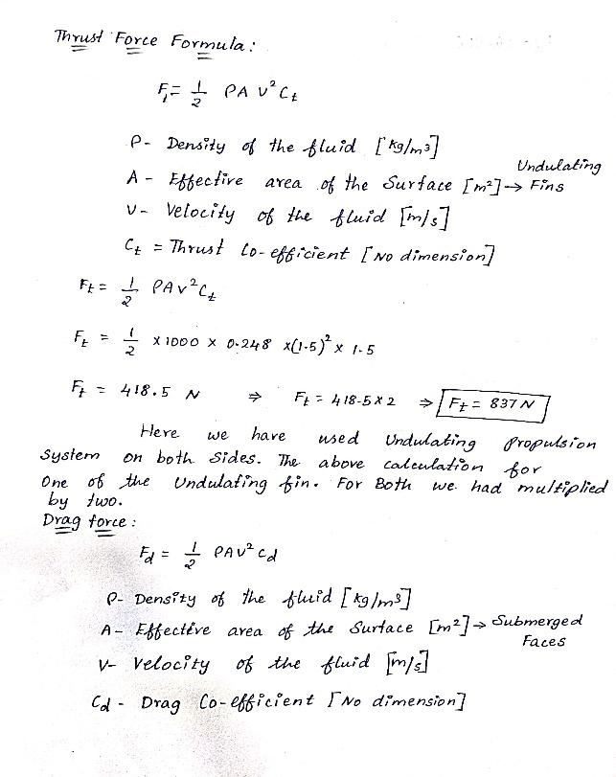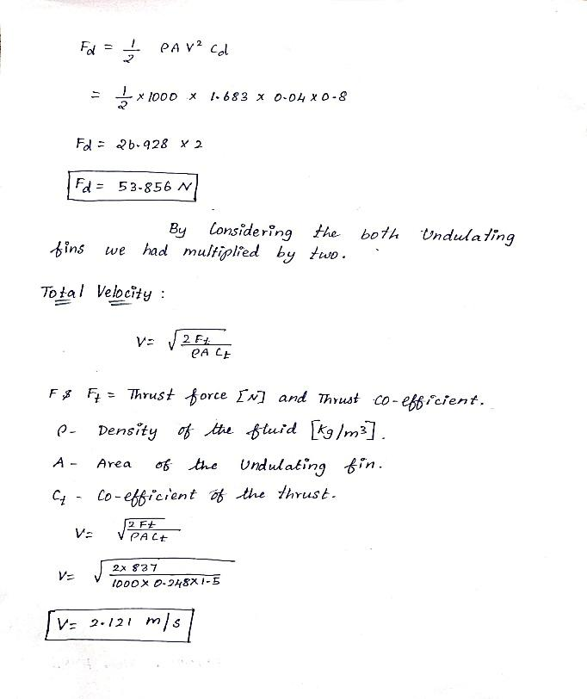

**3 4**

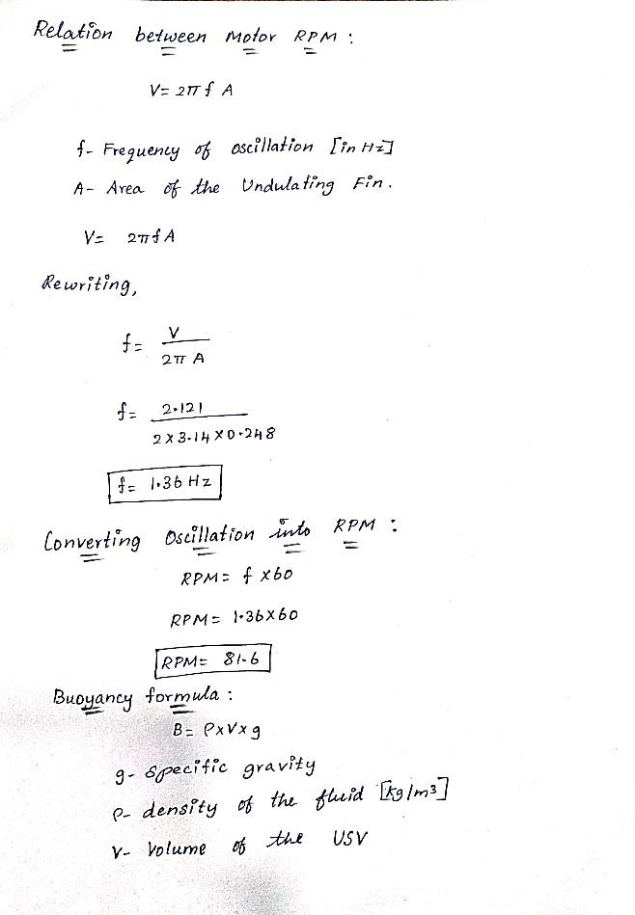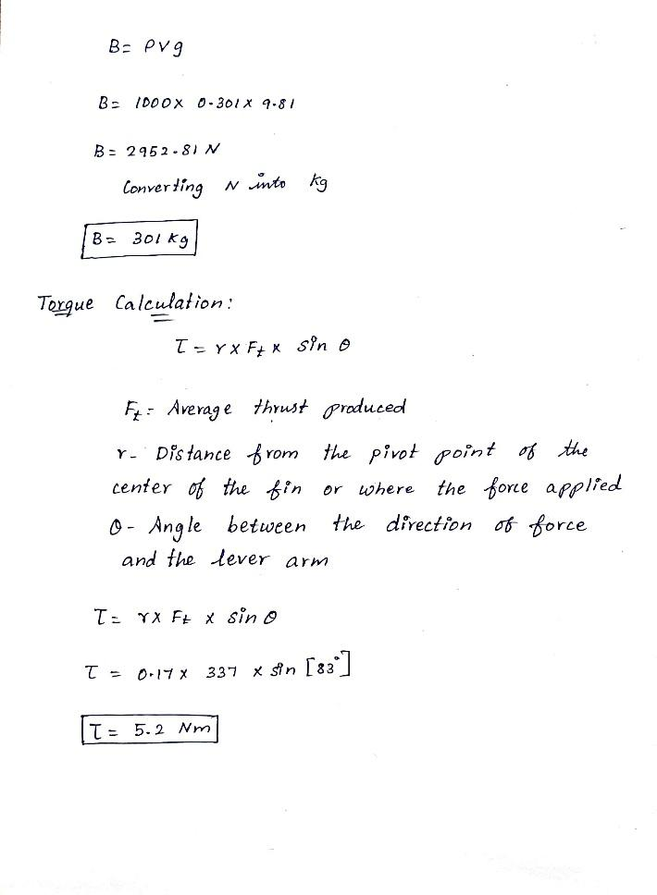

**Power Calculation:**

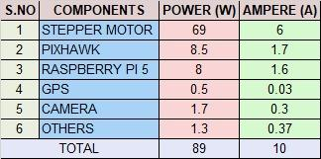

**Preliminary Analysis and Simulations:**

**Hydrodynamic and Structural Analysis:**

* **Drag Coefficient Testing:** Computational Fluid Dynamics (CFD) simulations confirmed that the hull and fin designs minimize water resistance, optimizing speed and efficiency for waste collection.
* **Finite Element Analysis (FEA):** Ensured the hull’s durability under potential forces from wave impact and collected debris.

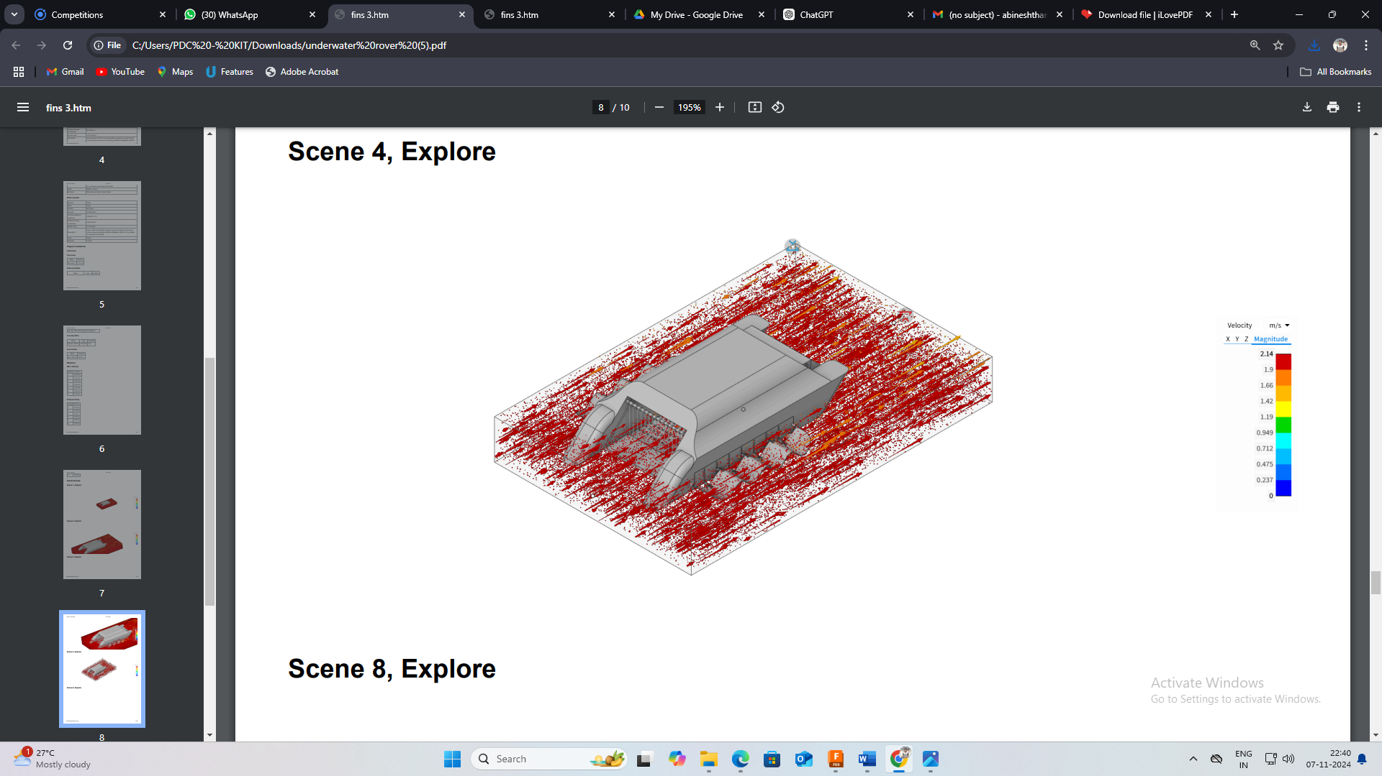

* 1. Velocity Flow

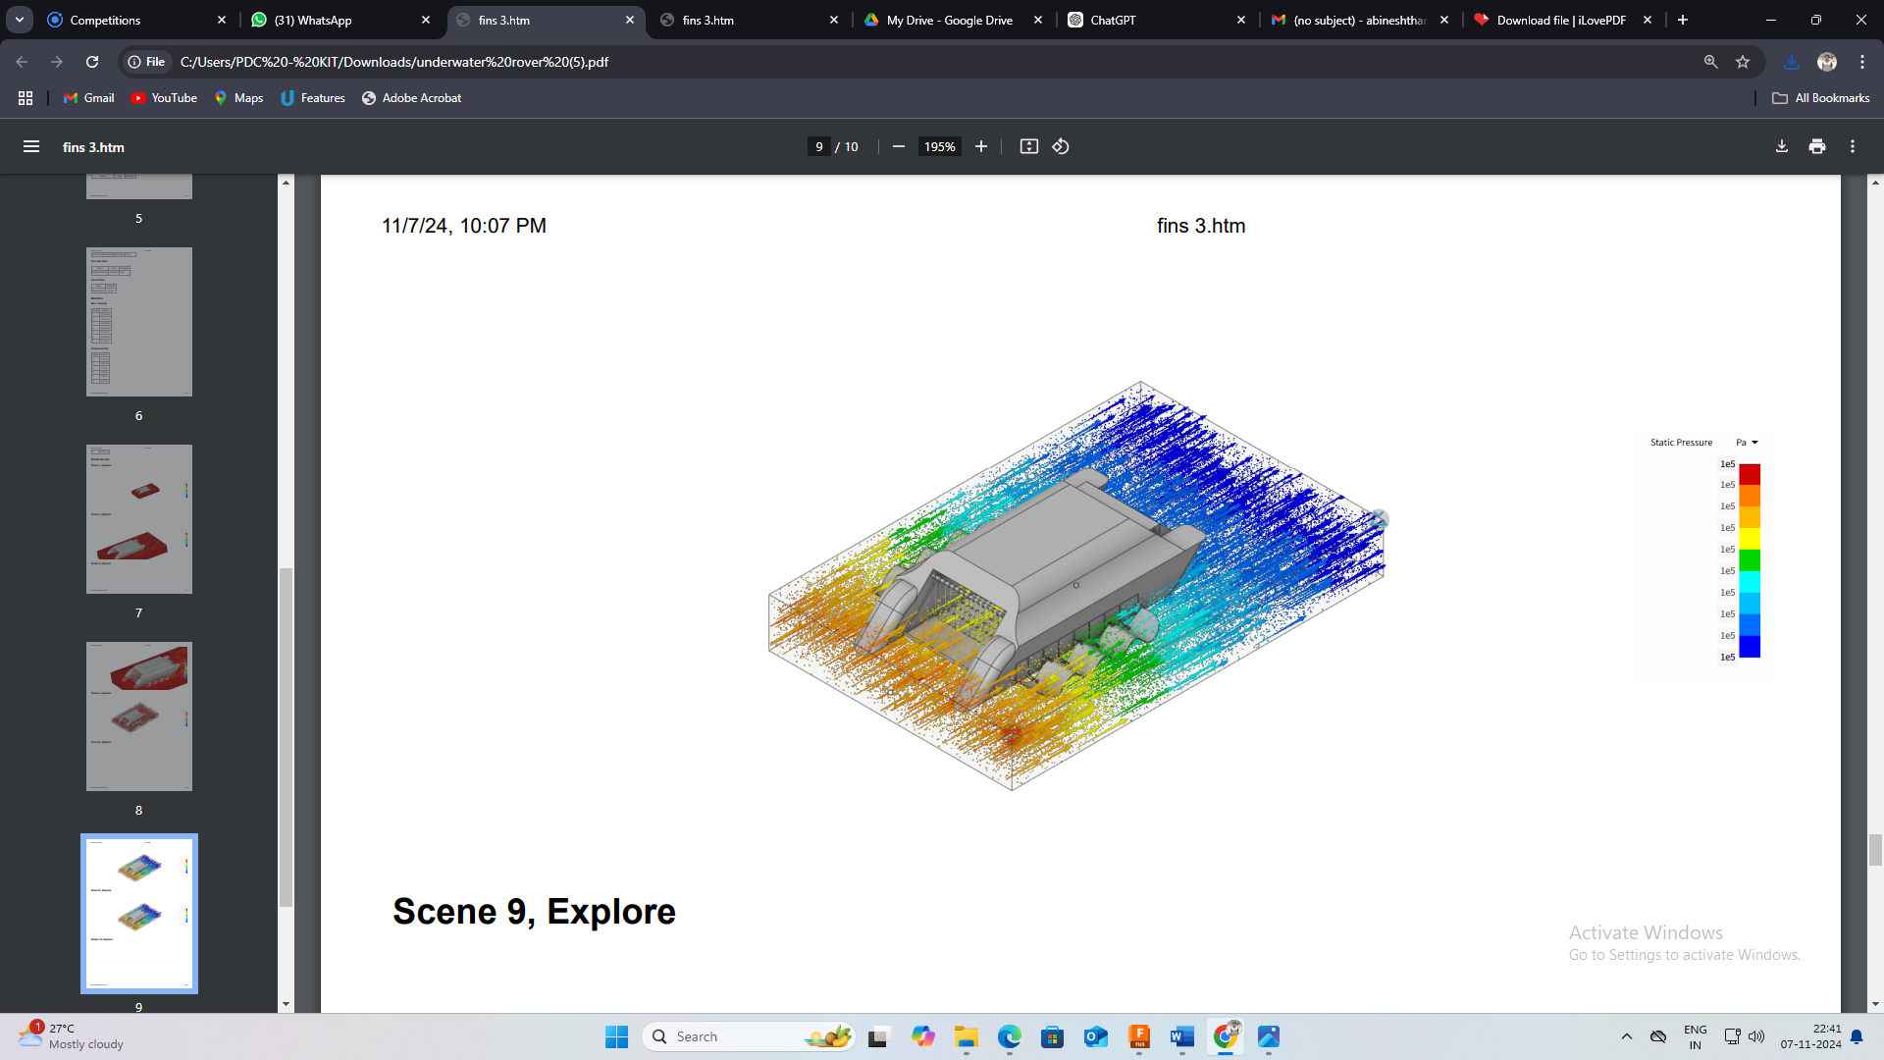

* 1. Static Pressure Flow

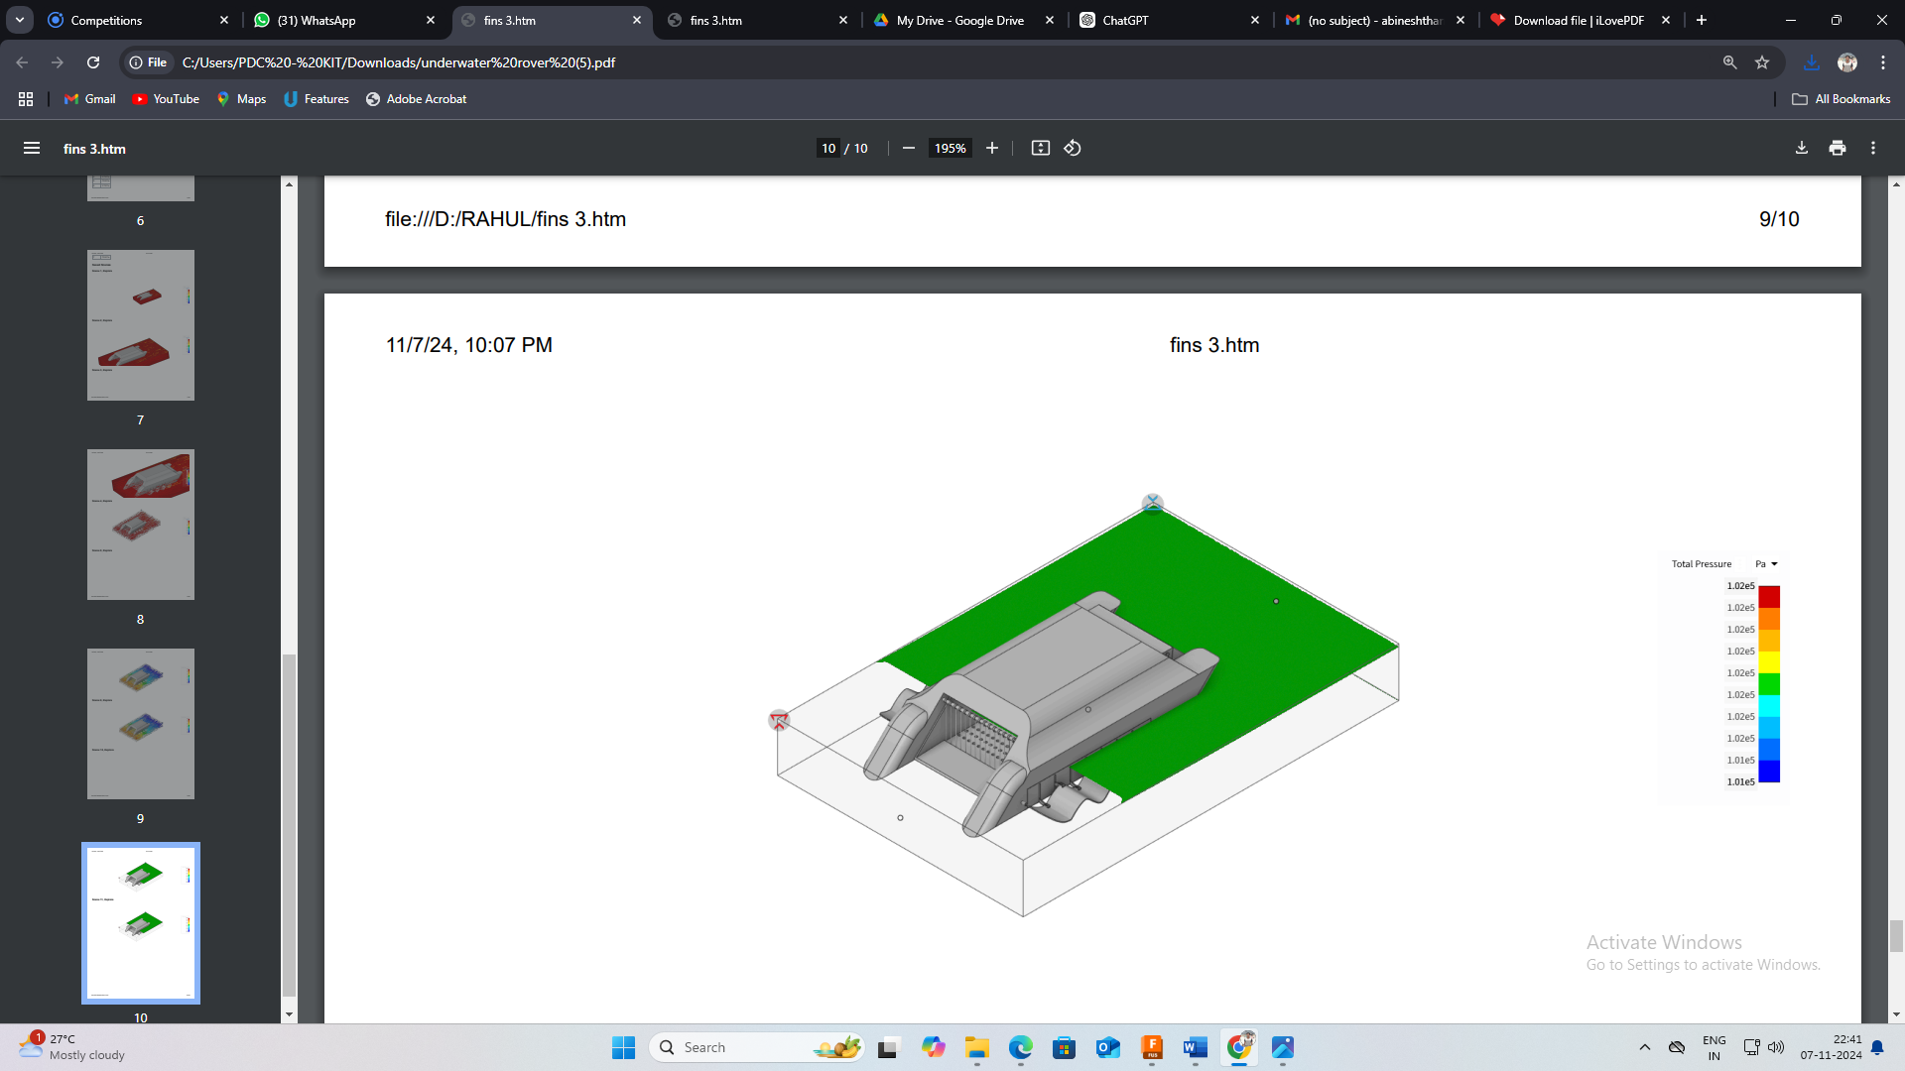

* 1. Drag Force

Source: [**Ansys report**](https://drive.google.com/drive/folders/1c0TCFmJtkoRIwsydG6TD-WpwEO76VcT6?usp=drive_link)

**Project Tentative Budget:**

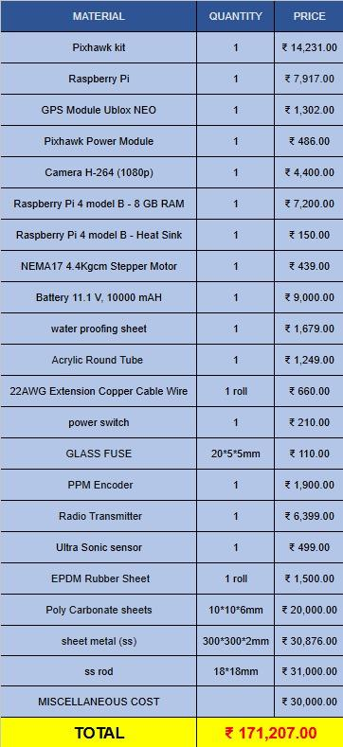

* **Production Cost**: ₹171,207 per unit.
* **Operational Expenses**: ₹85,000 - ₹100,000/month.
* **Revenue**: Sales, subscriptions, data analytics, recycling partnerships.
* **Expansion**: Pilot phase, regional expansion, nationwide growth.
* **Funding**: ₹50-70 lakh.

**Project Timeline:**

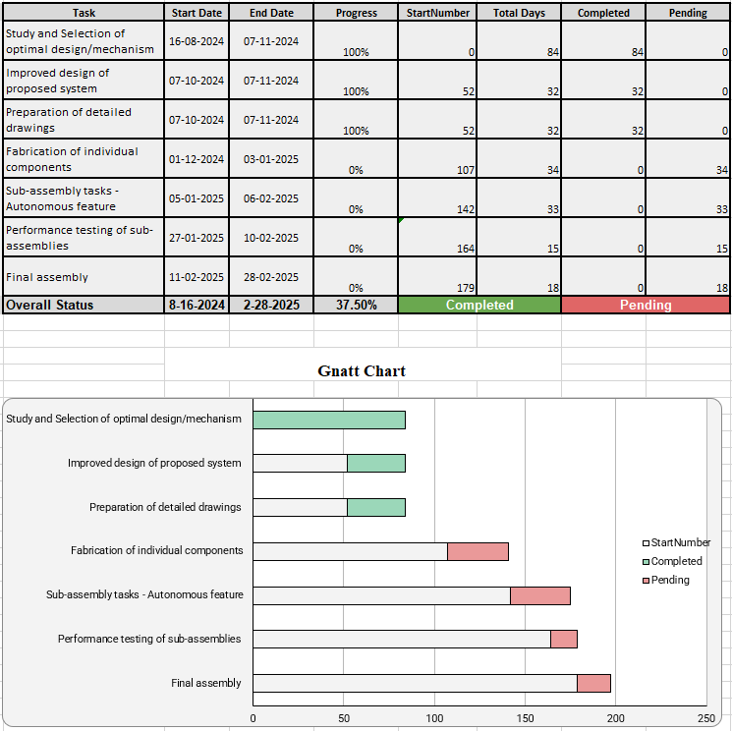

**Team Expertise:**

